Reflection W.S.

- Light from a flashlight shines on a mirror and illuminates one of the cards. Draw the reflected beam to indicate the illuminated card.
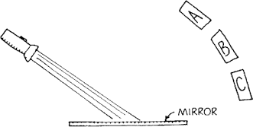

Which card would you see?

- A periscope has a pair of mirrors in it. Draw the light path from the object to the eye of the observer.
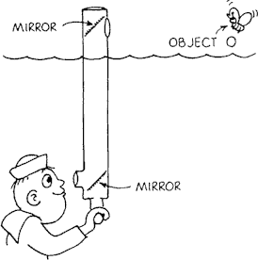

At what angle must each mirror be tilted?

- The ray diagram below shows one of the reflected rays from the plane mirror. Complete the diagram by drawing the three other reflected rays. (Assume that the candle and image are viewed by an observer on the left.)

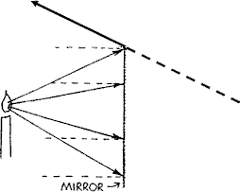

How far "behind the mirror" is your image located? (remember to measure along a normal - that is, along a line that is perpendicular to the mirror)

- The ray diagram below shows the reflection of one of the rays that strikes the parabolic mirror. Notice that the law of reflection is obeyed, and the angle of incidence (from the normal, the dashed line) equals the angle of reflection (from the normal). Complete the diagram by drawing the reflected rays of the other three rays that are shown.

Why are parabolic mirrors used in automobile headlights?

- A girl takes a photograph of the bridge as shown in the diagram below.
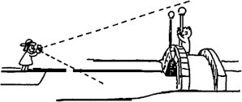

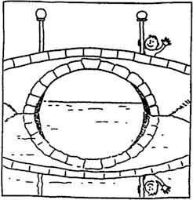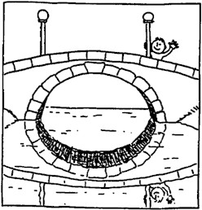

Which of these two sketches shown above correctly indicates the reflected view of the bridge? Defend your answer.
Abe and Bev both look in a plane mirror directly in front of Abe (left). Abe can see himself while Bev cannot see herself - but can Abe see Bev, and can Bev see Abe? To find the answer we construct their virtual locations "through" the mirror, the same distance behind as Abe and Bev are in front (right). If straight-line connections intersect the mirror, as at point C, then each sees the other. The mouse, for example, cannot see or be seen by either Abe or Bev.

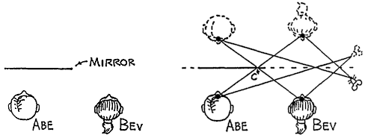

6. Refer to the following information for the next eight questions.

Here we have eight students in front of a small plane mirror.

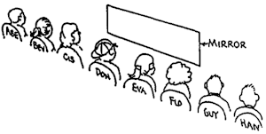

Their positions are shown in the accompanying diagram. As you answer the following questions, refer to the location of each appropriate straight-line construction on a sheet of notebook paper.

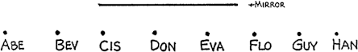

  - Who can Abe see?

Abe | Bev | Cis | Don | Eva | Flo | Guy | Han

  - Who can Bev see?
Abe | Bev | Cis | Don | Eva | Flo | Guy | Han

  - Who can Cis see?
Abe | Bev | Cis | Don | Eva | Flo | Guy | Han

  - Who can Don see?
Abe | Bev | Cis | Don | Eva | Flo | Guy | Han

  - Who can Eva see?
Abe | Bev | Cis | Don | Eva | Flo | Guy | Han

  - Who can Flo see?
Abe | Bev | Cis | Don | Eva | Flo | Guy | Han

  - Who can Guy see?
Abe | Bev | Cis | Don | Eva | Flo | Guy | Han

  - Who can Han see?
Abe | Bev | Cis | Don | Eva | Flo | Guy | Han

- Refer to the following information for the next six questions.
Six of our group are now arranged differently in front of the same mirror. Their positions are shown below. As you answer the following questions for this more interesting arrangement, refer to the location of each appropriate straight-line construction on a sheet of notebook paper.

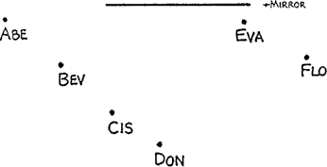

  - Who can Abe NOT see?
Abe | Bev | Cis | Don | Eva | Flo | Guy | Han

  - Who can Bev NOT see?
Abe | Bev | Cis | Don | Eva | Flo | Guy | Han

  - Who can Cis NOT see?
Abe | Bev | Cis | Don | Eva | Flo | Guy | Han

  - Who can Don NOT see?
Abe | Bev | Cis | Don | Eva | Flo | Guy | Han

  - Who can Eva NOT see?
Abe | Bev | Cis | Don | Eva | Flo | Guy | Han

  - Who can Flo NOT see?
Abe | Bev | Cis | Don | Eva | Flo | Guy | Han

8. Refer to the following information for the next question.
Mr. Lindsay views himself in a full-length mirror. Show where you
Should construct straight lines from Mr. Lindsay’s eyes to the image of his feet, and to the top of his head. Then determine the minimum area of the mirror which Mr. Lindsay uses to see a full view of himself.

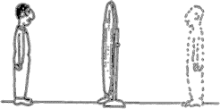

Does this region of the mirror depend on Harry's distance from the mirror?
- Mrs. Drake stands 1 meter in front of the dresser mirror and looks at the flower on the back of her head in a small hand held ½ meter in back of her head.
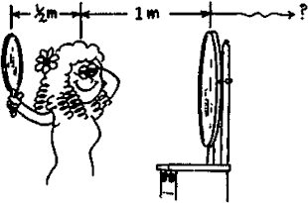

How far in back of the dresser mirror does she see the image of the flower?
Refer to the following information for the next five questions.

Match the correct definition to each word.
- θ_{i} = θ_{r}
- produces diffuse reflections when the difference in successive elevations is greater than or equal to 1/8th of the incident wavelength
- an image which is "trapped" inside a mirror that is formed by our eyes when they "dot back" the diverging rays that are reflected by a mirror.
- d_{i} = -d_{o}
- rays that spread apart from each other

- . Law of Plane Mirrors

A | B | C | D | E

- . Law of Reflection

A | B | C | D | E

- . rough surface

A | B | C | D | E

- diverging rays

A | B | C | D | E

- virtual image

A | B | C | D | E
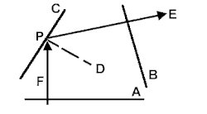
Refer to the following information for the next nine questions.

Law of Reflection
- reflected wavefront

A | B | C | D | E | F

- incident ray

A | B | C | D | E | F

- interface

A | B | C | D | E | F

- normal

A | B | C | D | E | F

- angle of reflection

CPE | DPE | FPD | CPF

- What is the size of the angle between any ray and its wave-front?

- What is the size of the angle between any normal and its interface?

- What is the relationship between the angle of incidence and the angle of reflection?

- True or False? Diffuse reflections obey the Law of Reflection?

True | False

- Two plane mirrors form the legs of a 60º angle. When an object is placed between these two mirrors, what is the maximum number of images that could be viewed while looking into the mirrors?

- What is the minimum length of a plane mirror required for someone to see their entire body WITHOUT moving their head?

- Which of the following are properties of virtual images formed by plane mirrors?

they are inverted
they are upright
they are left-left and right-right consistent
they are left-right reversed
they are enlarged in size
they are equal in size to the object
they are reduced in size
they are located closer to the back of the mirror than the object is in front of the mirror
they are located as far behind the mirror as the object is in front of the mirror
their frequencies (colors) remain the same
their frequencies (colors) are reversed with their complementary colors
they are formed by converging rays
they are formed by diverging rays

- For regular reflection, what is the case with an angle of incidence of .
  - 0⁰
(b) 90⁰
- If the moon had a very smooth surface, how would a full moon appear?

- When you look at a rear-view mirror, (above the dashboard), in your car at night, two similar images, one behind the other, are often seen. Why are there two images? (Hint: the glass is thick and triangular).

- (a) If you walk toward a plane, full-length mirror, what does your image do?

- How fast does the image move?
- Is the image in step with you (like marching in a band?
- In detective movies and also in the study of children’s activities, one-way mirrors are used for secret observations. (A one-way mirror is seen as a mirror from one side but can be seen through from the other side.) Reflecting sunglasses are another example. How do one-way mirrors work? (Hint: At night a glass windowpane is a one-way mirror.)

- A good reflecting surface such a plane mirror has a reflectivity of about 90 percent, or 10 percent of the incident light is absorbed on reflection. If four mirrors are set up so that an incident beam is reflected from one to the other, what percent of the incident light energy will be reflected form the fourth mirror? (Hint: The answer is not 60 percent).

- Explain the purpose of dual truck mirrors, as shown below:
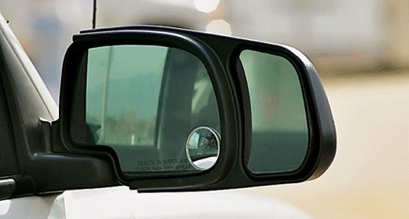
- Operating room and dentist’s lamps have large spherical reflectors. What is the purpose of these?

- A dentist sometimes uses a small converging spherical mirror to examine cavities when filling them. What is the advantage of a converging mirror over a plane mirror?

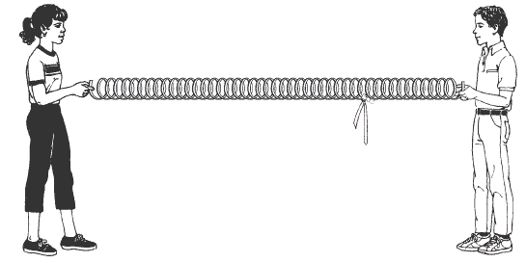
36. REVIEW: The drawing below shows two students holding the ends of a spring that has a ribbon attached to it.
- Draw and explain how a transverse wave will move along the spring.

- Draw and explain how the ribbon will move when a transverse wave is sent along the spring.

- Draw and explain how a longitudinal wave will move along the spring.

- Draw and explain how the ribbon will move when a longitudinal wave is sent along the spring.

- REVIEW: Which of the following graphs best represents the relationship of the frequency of an electromagnetic wave to its wavelength?

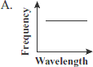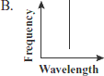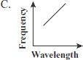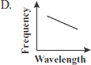
- Ultraviolet light has a shorter wavelength than visible light. Which of the following is another way ultraviolet light can be compared to visible light?

A. Ultraviolet light has a lower frequency than visible light.
B. Ultraviolet light has a higher frequency than visible light.
C. Ultraviolet light travels faster than visible light.

